**ENEL 453 Laboratory 3**

Lab Section 02

Benjamin Hilborn and Brendon Kopp

**Lab held on february 24th, 2015**

We declare that this laboratory report is entirely our own work and includes no material which has been copied from any other source excepting that material which is clearly identified as the work of others.

# 6. Simulate the VGA Display Component

Testing reset:

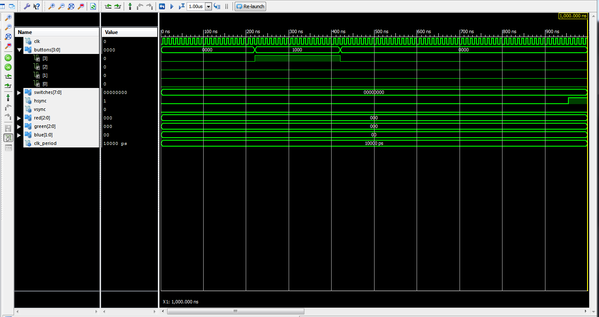

All signals are properly defined, and the button is properly linked to the reset signal.

Testing HSYNC:

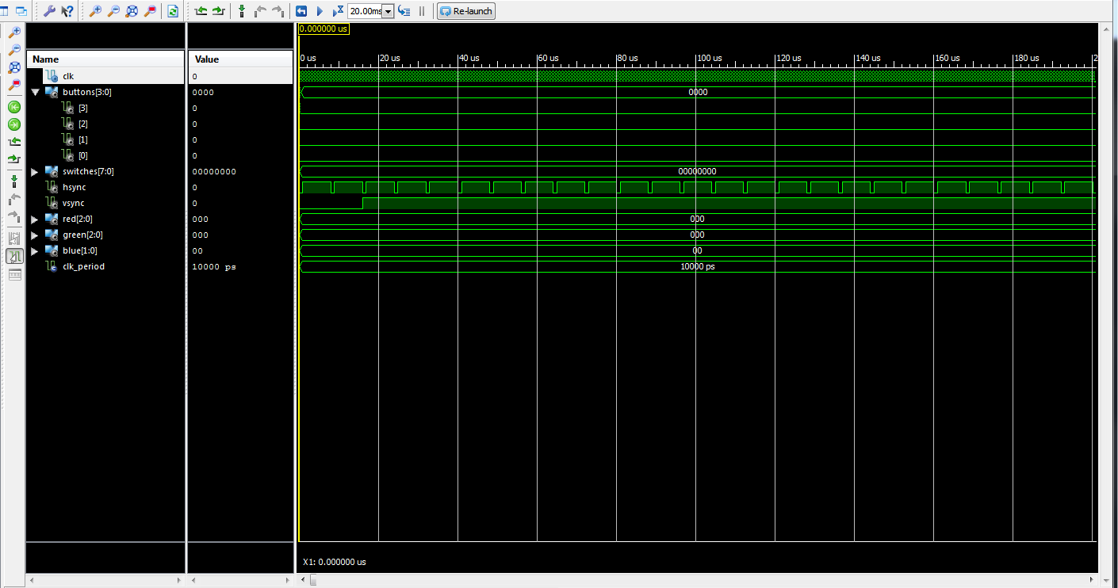

Testing VSYNC:

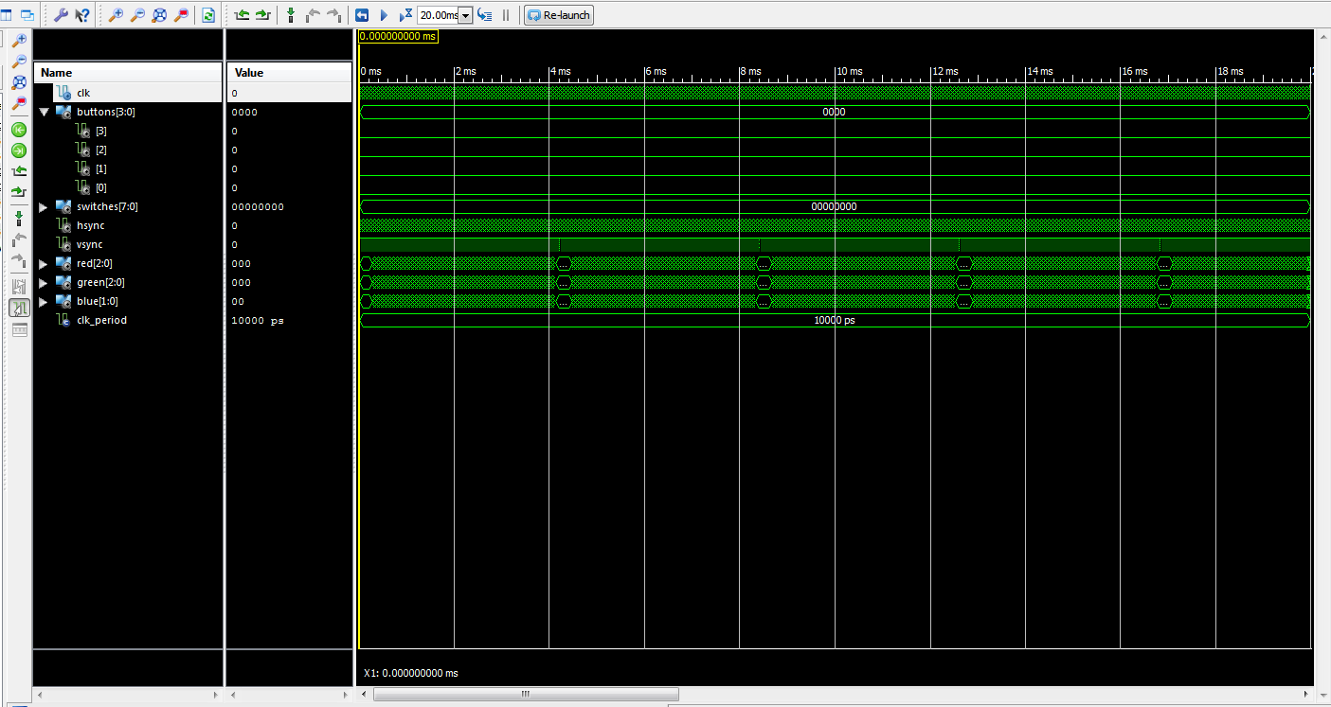

Testing that Switches Select the Box Colour:

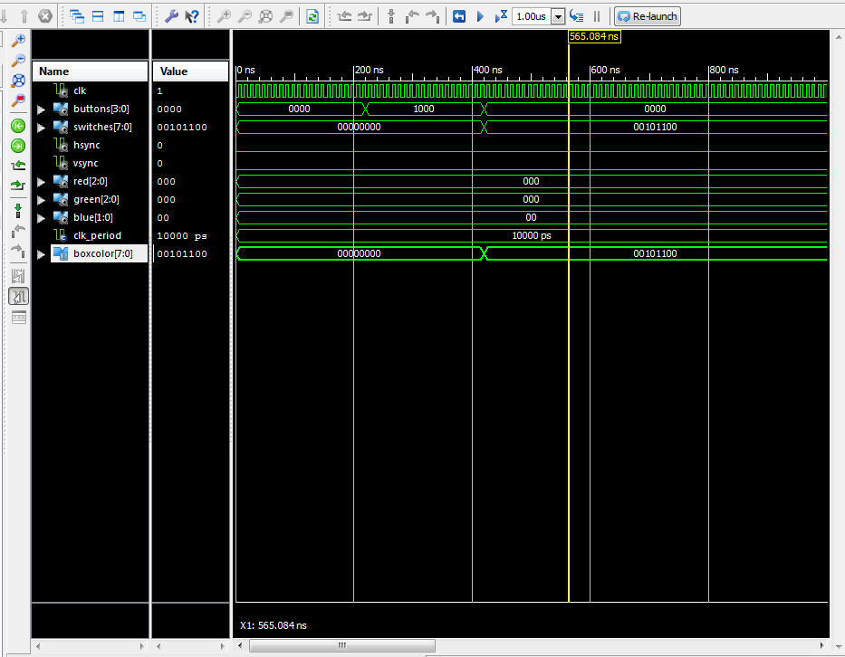

You can clearly see the boxcolour change when switches changes value. When switch positions are changed, this changes the mixing of colour signals to the box.

Testing that Buttons Change Box Size:

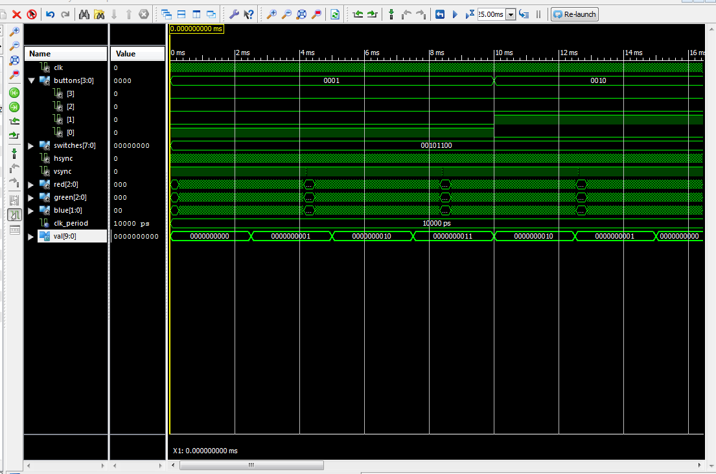

As button(0) is held, you can see val increase in value, and decrease in value as button(1) is held.

Testing Mode Selector:

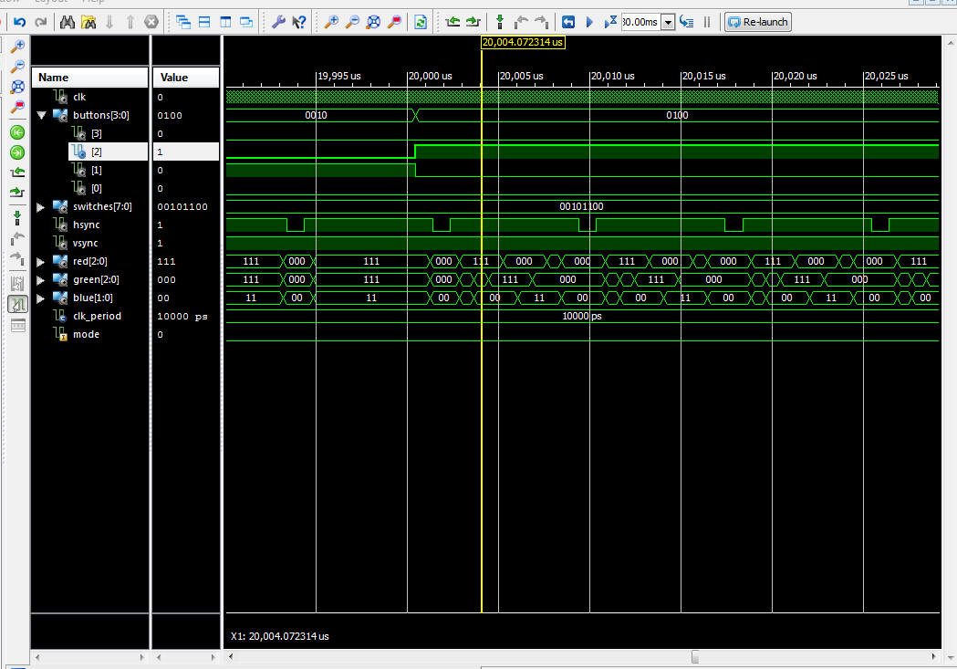

When button(2) is held, it is changing the mode to display stripes. It’s easy to notice the change in pattern of the colour signals, associated with displaying striped on the screen.

Testing Blanking:

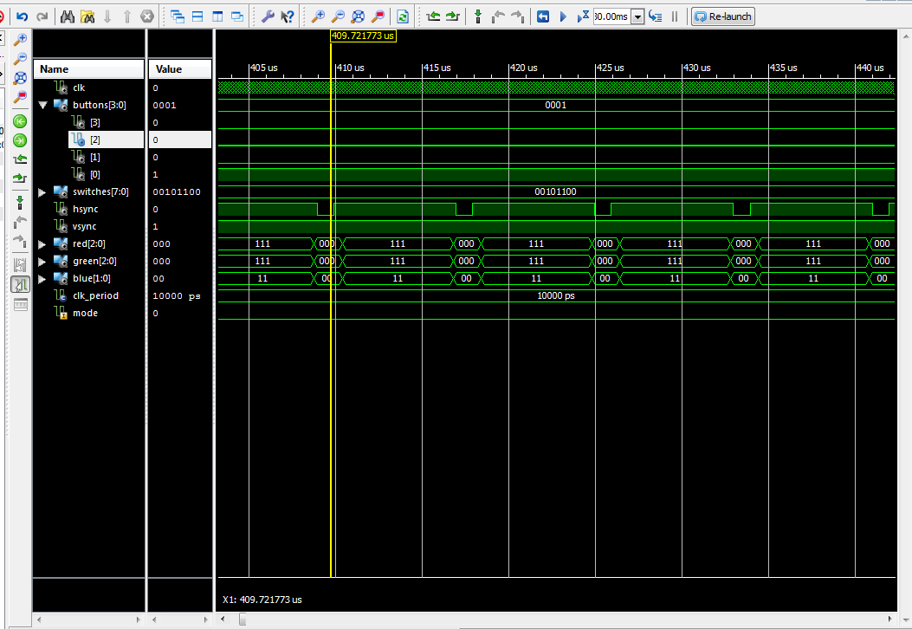

You can clearly see that when blanking is held, the screen is blanked, showing no colour.

# 8. Showing that module still operates properly

Due to the way we did our lab, the screenshots above were all taken after we had programmed the board and confirmed it worked.

# 10. Additional questions

1. The monitor receives 640 HSYNC pulses before it receives one VSYNC pulse, telling it that there are 640 pixels per line.
2. We just have to change the values for HDisplayArea and VDisplayArea in the sync_signals_generator file.
3. VSYNC changes after 640 “ticks” of the HSYNC signal. This change in VSYNC tells the monitor to start writing pixels to the next line down.
4. 1/25000000 * 640 * 480 = 0.0123s. This tells us that the maximum refresh rate at this resolution is approximately 81 fps.
5. Human eyes are more sensitive to reds and greens, meaning that we would more easily notice a lower colour resolution in those colours.
6. One-hot encoding has only one “hot” bit, meaning that the state doesn’t need to be decoded, allowing for faster use. Gray encoding changes only one bit at a time, keeping equal timing across all counts.